Create Vector Index & Data Ingestion Pipeline

Option A — Portal-first approach, recommended for you now

Use the Azure AI Search or Foundry “import and vectorize” workflow.

High-level steps:

Open Azure AI Search.
  - Login to Azure Portal.
  - Enter Azure AI Search in Azure Portal Search bar and select AI Search (Foundry IQ).
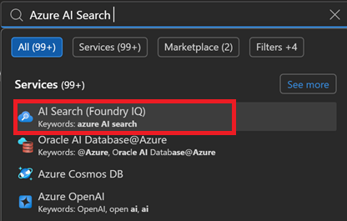

Select your AI search service.
  - Select Azure AI Search resource.
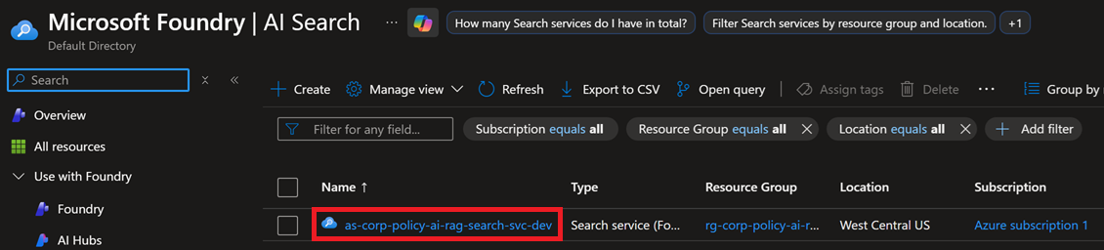

Select data import/ingestion RAG scenario.
  - Select Import data to select data source.
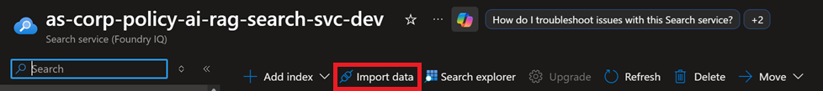
  - Click Azure Blob Storage option.
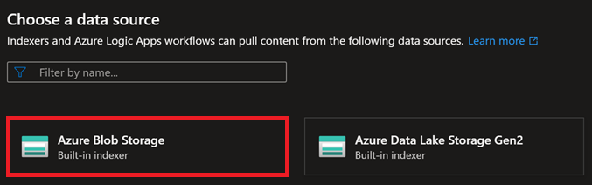
  - Select RAG solution scenario.
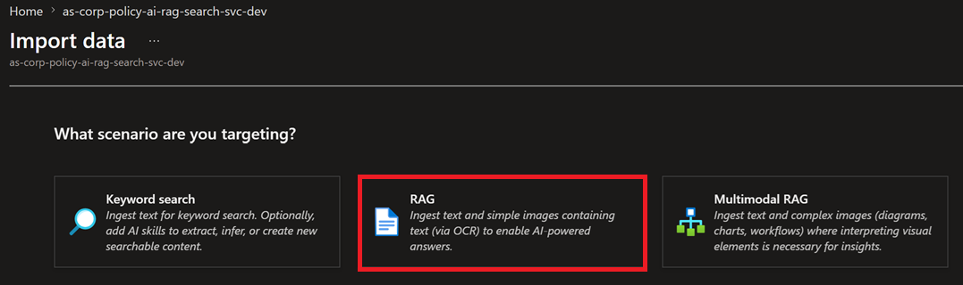

Configure Azure Corp Policy blob storage.
  - Enable the following RAG settings:
    - Select Subscription.
    - Select Storage Account.
    - Select Blob container.
    - Select Parsing mode.
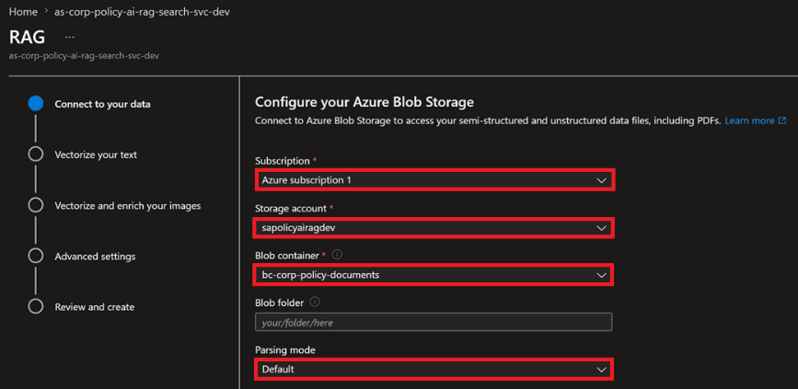
  - Enable the following Blob Storage configurations:
    - Select Enable deletion tracking.
    - Select Native blob soft delete.
    - Select Authenticate using managed identity.
    - Select System-assigned.
    - Click Next button.
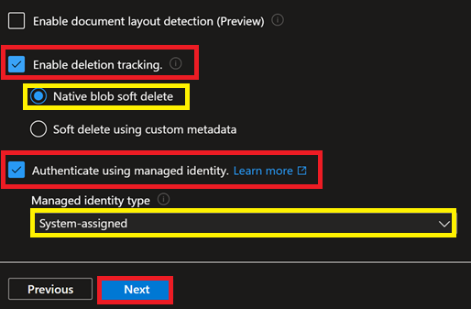

Configure vectorize text ingested/pulled from blob storage.
  - Select the following Vectorize Text settings:
    - Select resource Kind.
    - Select cloud/Azure Subscription.
    - Select the Microsoft Foundry service/project containing your embedding.
    - Select your Embedding Model deployment.
    - Select your Authentication type.
    - Select I acknowledge that connection a Microsoft Foundry resource will incur additional cost t my account.
    - Click Next button.
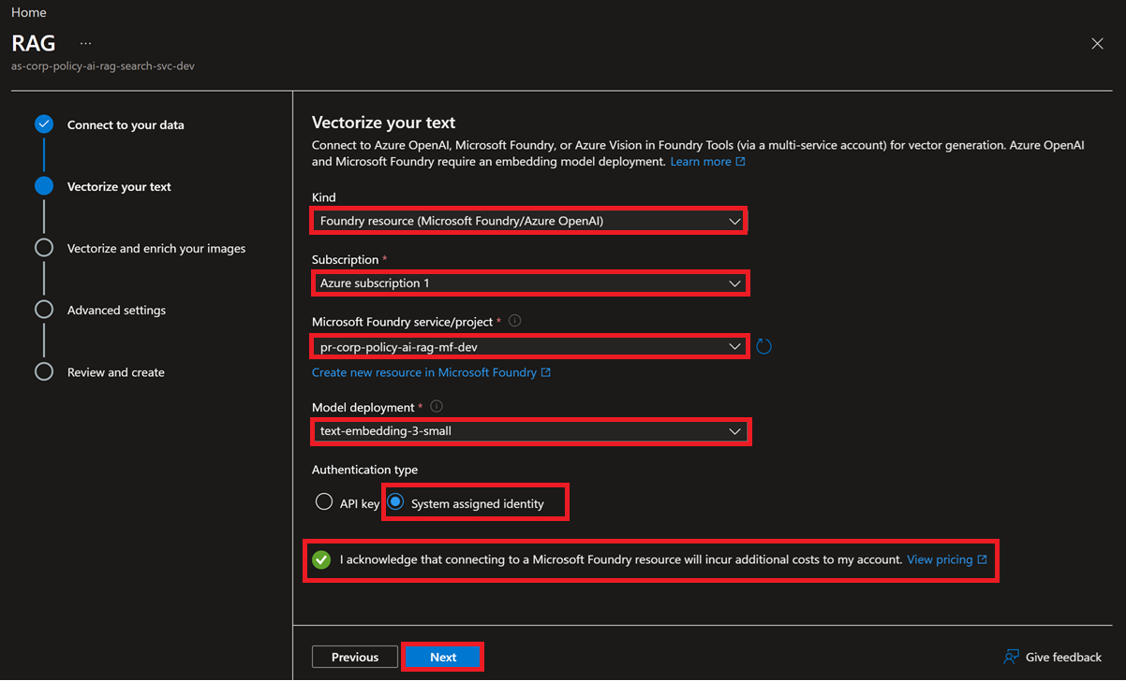

Vectorize and enrich image data.
  - Vectorize images and Extract text form images unchecked. Click Next button.
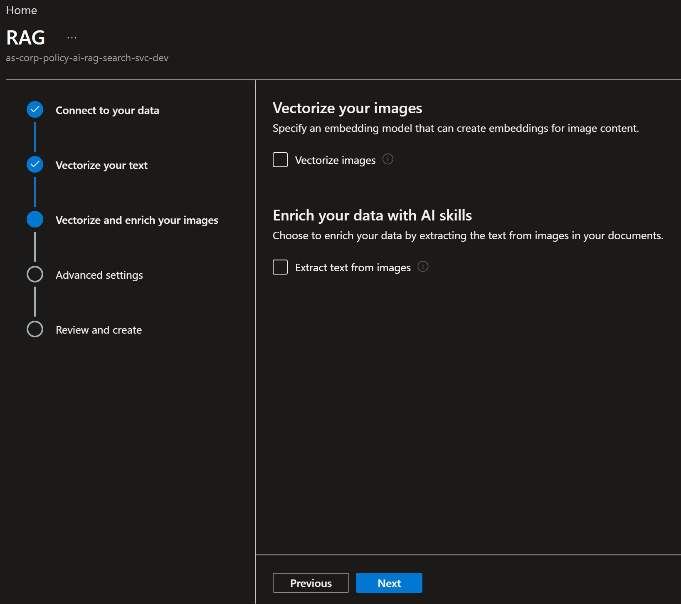

Enable advanced ranking, preview index fields, and index scheduling.
  - Click Enable semantic ranker and select ScheduleDaily. Click Next button.
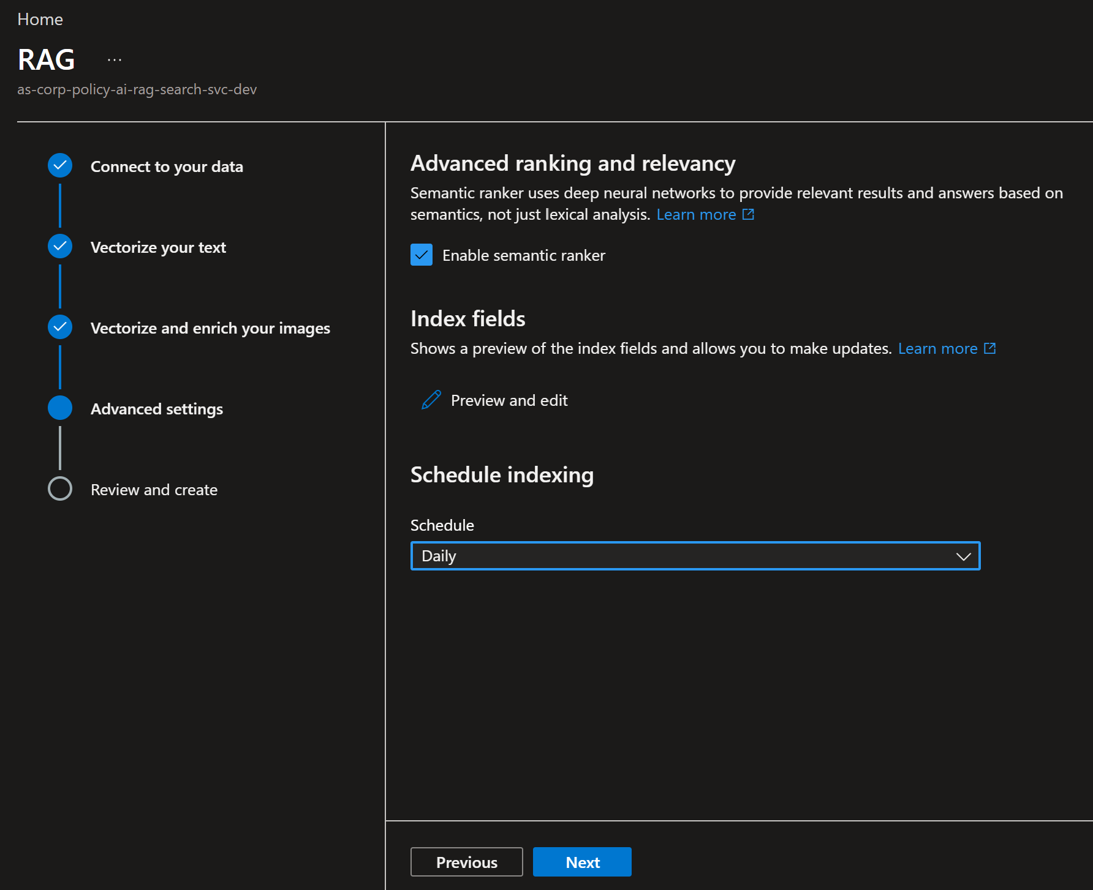

Create Vector Index.
  - Click Create button to create the Vector Index.
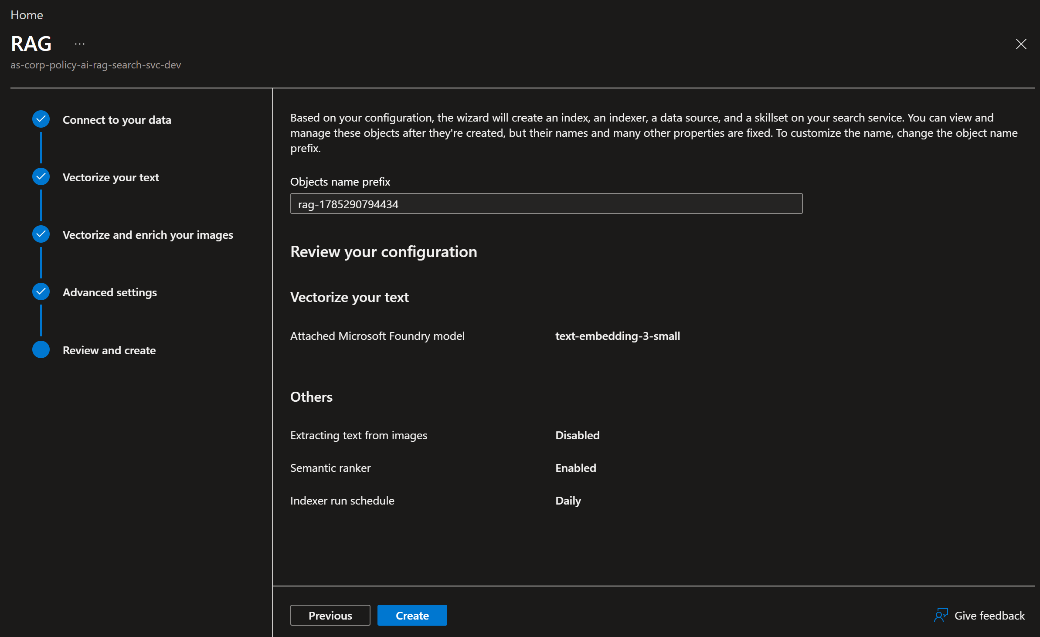
  - Click Go to Search explorer button.
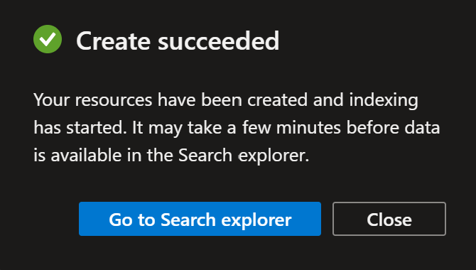

Run the vector indexer.
  - Enter a Policy Test Query to verify connection to the corporate policy -data source and that the Vector Indexer is working properly.
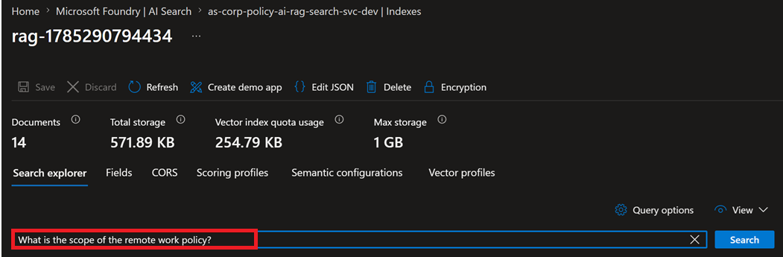
  - See Policy Test Query results.
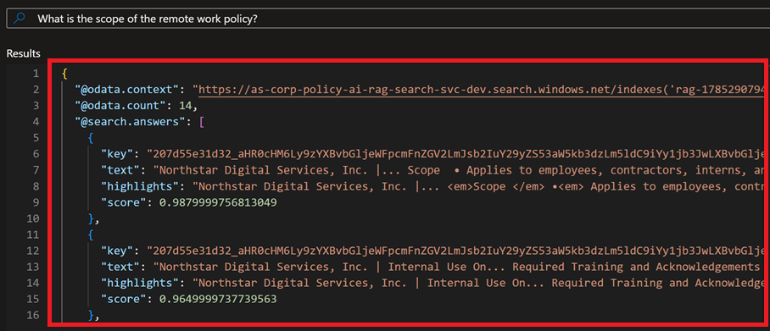
  - Finished.

